CLASS: BE (E&TC) SUBJECT: MC
EXPT. NO: 06 DATE:

I. TITLE: HANDOVER MECHANISM

II. OBJECTIVE: Demonstrate handover mechanism and record the performance parameters like SNR
for call drop scenario

III. SOFTWARE USED: Operating System: Windows 7
Software: Java Version 6
Mozilla Firefox: version: 47.0.1
or
Compatible mode for above specification

Link to download software:
https://drive.google.com/uc?id=0B9mNeu43jUidckFYVTlnenpJRGs&export=download

IV. THEORY:
Handoff
Consider the figure below Initially say the mobile M is quite close to the base station A and hence receives signal strength from A PArx > PBrx . As the mobile moves away from the base station. A and goes towards B then the signal strength from A keeps falling (pathloss increases).Let there be a minimum sensibility level P0rx0 for the mobile, i.e. if the signal from the B.S.to which the mobile is connected falls below P0rx0 then the call drops. In order to prevent call drop the mobile monitors receive signal strength from the neighboring 3-6 BS. These neighboring 3-6 BS also monitor Rx signal strength from the MS.

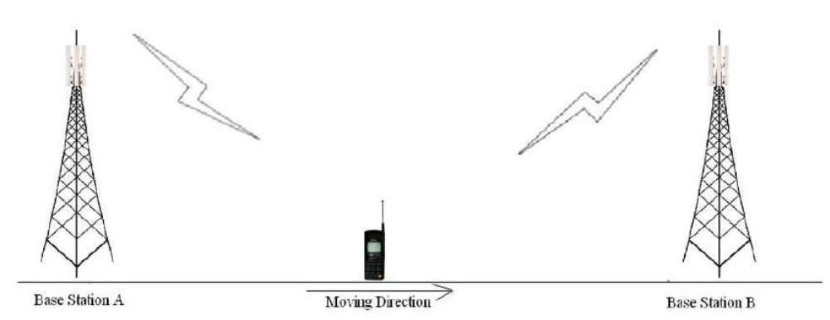

The mobile should get connected to BS which has the highest signal strength. However, if the MS continuously attaches itself to the BS with instantaneous height signal strength then the h/o rate may very high in server condition.
Thus, Hysten's condition is used for h. If PTrx (T= target BS) > Phrxℎ-max (higher h/o threshold) and Pcrx (c=current BS) < Phrxℎ-min (minimum h/o threshold) then execute h/o to BST from BS. Thus, it is threshold impeditive to study in part of the handoff process.

Δγ= Phrx – PlrxΔ = ℎ

A successful handoff is one where the call gets continued without call drop or in other words the h occurs before h/o Pcrx becomes < P0rx < 0. If Pcrx < P0rx0 then call drop event occurs. One would like to minimize the no of handoff events as well as minimize call drop probability. The experiment provides opportunity to study the inherent of these three parameters on h/o.
Further the averaging window for calculating PTrx and Pcrx also plays a role in the process. In the experiment small scale fading is not considered and hence the averaging considered only shadowing. The impact of small scale fading and shadowing on h/0 can be studied theoretically.

Follow the instructions given below to perform the experiments.
Step1: Click on START button to start experiment


Step2: Enter your name then click OK button.

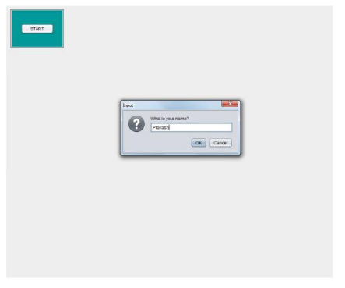
Step3: Select the parameters (e.g.: Reuse, Environment, Beamwidth, Carrier frequency etc.)

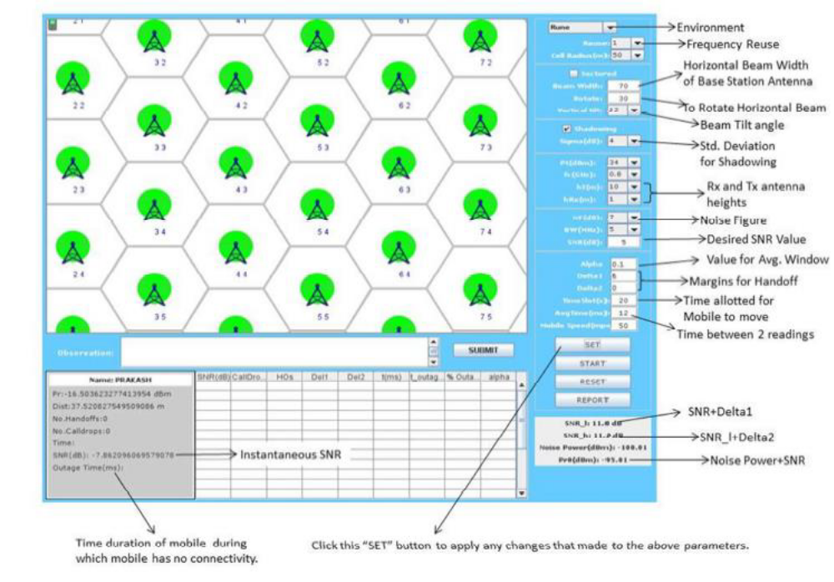
Step4: Click on START button and observe No. of Call Drops and No. of Handoffs.
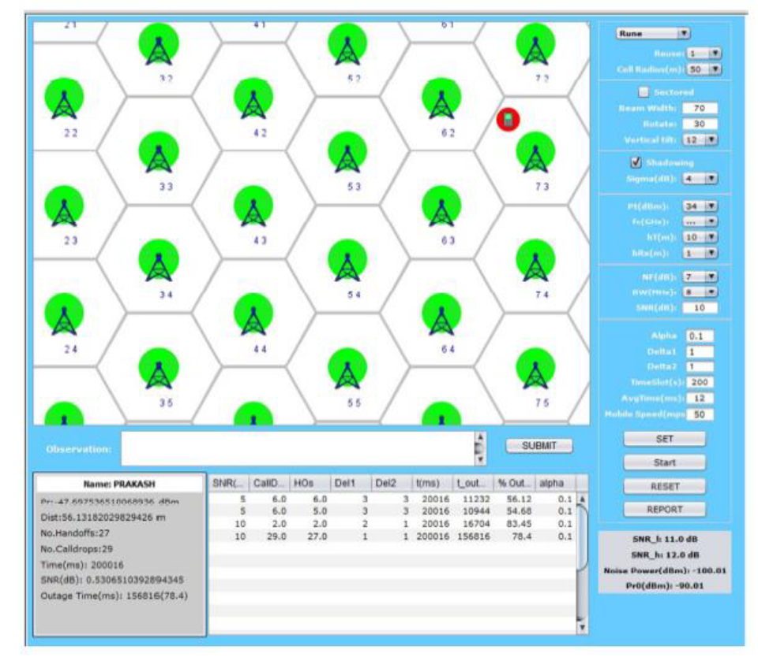

Step5: Enter your observation in the OBSERVATION box and Click on SUBMIT button.

Step6: Finally, click on REPORT to generate PDF report of the experiment.

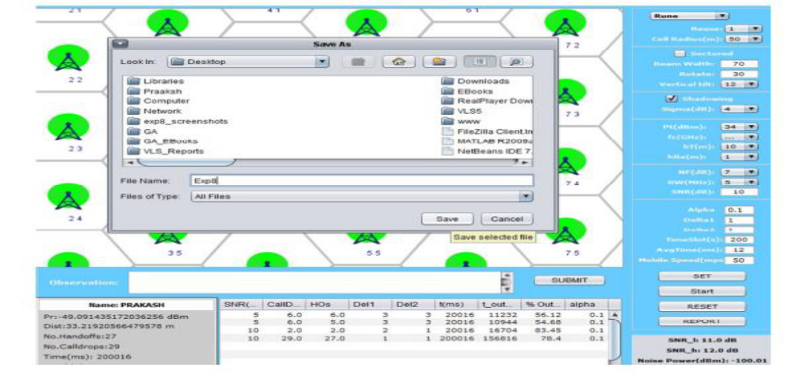

Step7: After PDF report generation you will get following message.

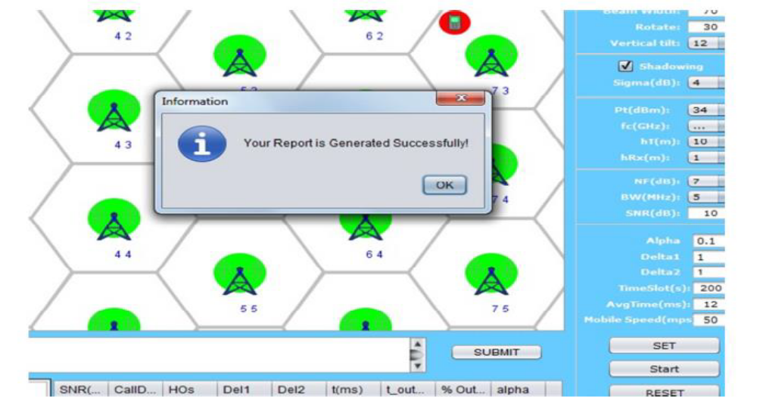

Step8: PDF report will appear like this.
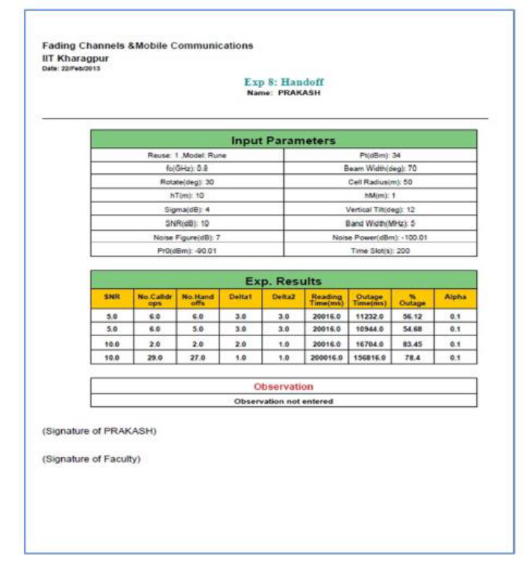

Step9: To redo experiment click on RESET button.

V. RESULT
Observation Table:
Specify reuse and record the data for first two readings.
Keeping reuse = 3, specify mobile speed as 50 and 100 and record the data for further two readings.
Tabulate all the records as given in below Table.

Sr. No. | Reuse | Mobile Speed | No. of Handoff | Outage | Outage Percentage
1 | 1
2 | 3
3 | 3 | 50
4 | 3 | 100

VI. CONCLUSION:

SIGNATURE

REFERENCES:
1. “Mobile Communications” – Jochen Schiller

